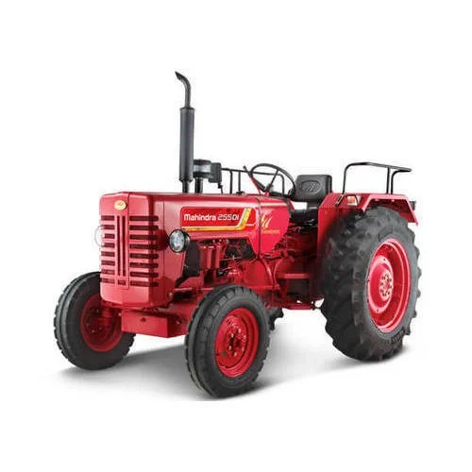

Meta Title
Mahindra Arjun 605 DI, 555 DI & Ultra Silencer | Tractech Spares

Meta Description
Buy heavy-duty silencers for Mahindra Arjun 605 DI, 555 DI, and 555 DI Ultra online. Get durable, OEM-grade tractor exhaust systems at the best price on Tractech Spares.

2. On-Page Product Details

Optimized Product Title (H1 Header)
Heavy-Duty Silencer / Exhaust Muffler for Mahindra Arjun (605 DI / 555 DI / 555 DI Ultra)

Product Description
Upgrade Your Tractor’s Performance with Premium Mahindra Arjun Silencers
Keep your tractor running smoothly and efficiently with our heavy-duty replacement silencer, specifically engineered for the Mahindra Arjun 605 DI, 555 DI, and 555 DI Ultra models. Crafted from high-grade, corrosion-resistant metal, this exhaust muffler ensures optimum backpressure, reducing engine noise while maximizing fuel efficiency during heavy farm operations.
Whether you are replacing a rusted exhaust or upgrading for better durability, Tractech Spares delivers OEM-matching quality that stands up to the harshest field conditions.

Key Features & Benefits:
- Perfect Compatibility: Precision-engineered to fit Mahindra Arjun 605 DI, 555 DI, and 555 DI Ultra models seamlessly.
- Heavy-Duty Build: Built with premium quality, rust-resistant steel for a longer lifespan and maximum heat tolerance.
- Optimized Exhaust Flow: Designed to reduce engine noise and vibration without compromising horsepower.
- Easy Installation: Direct-fit design allows for a quick, hassle-free replacement process.

Product Specifications:
- Brand: Tractech Spares (Premium Replacement)
- Compatible Tractor Brand: Mahindra
- Supported Models: Arjun 605 DI, Arjun 555 DI, Arjun 555 DI Ultra
- Material: High-Grade Industrial Steel
- Finish: Heat-Resistant Protective Coating

Pro-Digital Marketing Tips for Tractech Spares:
- URL Slug Structure: Keep it clean and SEO-friendly. Use: [tractechspares.com/products/mahindra-arjun-605-555-di-silencer](https://tractechspares.com/products/mahindra-arjun-605-555-di-silencer)
- Image Alt Text: Don't leave your images blank! Name your product image: mahindra-arjun-tractor-silencer-tractech-spares.jpg
- Keywords to target in your backend tags: Mahindra tractor parts online, Arjun 605 di silencer price, tractor exhaust pipe, Mahindra 555 ultra silencer replacement.

2

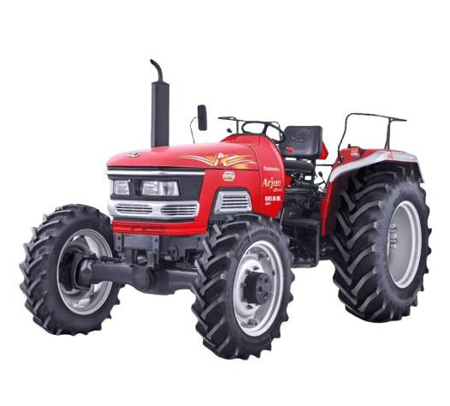

1. Meta Data (For Search Engines)

Meta Title
Mahindra DI 475, 575, 265 Silencer Elbow (Ref 8104) | Tractech Spares

Meta Description
Buy the Exhaust Silencer Elbow for Mahindra DI 475, 575, and 265. Premium quality, heavy-duty tractor exhaust bend pipe at Tractech Spares.

2. On-Page Product Details

Optimized Product Title (H1 Header)
Heavy-Duty Exhaust Silencer Elbow for Mahindra Tractor (DI 475 / 575 / 265)

Product Description
Premium Replacement Exhaust Silencer Elbow for Mahindra DI Series Tractors
Ensure a leak-free, high-performance exhaust system with our premium replacement Exhaust Silencer Elbow specifically built for Mahindra DI 475, 575, and 265 tractors. This critical connector pipe links your manifold seamlessly to the main muffler unit, preventing hazardous exhaust leaks and maintaining proper engine pressure.
Manufactured to meet rigid industry standards, this silencer bend features a durable dual-bolt flange base designed for an air-tight, vibrating-resistant fit during heavy agricultural operations.

Key Features & Benefits:
- Exact Fitment: Engineered as a direct swap for Mahindra 265 DI, 475 DI, and 575 DI models.
- Heavy-Gauge Construction: Fabricated from thick, robust metal to withstand extreme exhaust temperatures and prevent early burnout.
- Sturdy Flange Base: Dual-bolt mounting holes ensure a tight seal with the manifold, reducing vibrations and annoying exhaust rattles.
- Rust-Resistant Finish: Coated with a protective layer to resist corrosion from moisture, heat, and outdoor elements.

Product Specifications:
- Brand: Tractech Spares (Premium Aftermarket)
- Reference Number: TTSM-265/S
- Compatible Tractor Brand: Mahindra
- Supported Models: Mahindra DI 475, Mahindra DI 575, Mahindra DI 265
- Component Type: Exhaust Bend / Silencer Elbow / Flange Pipe
- Mounting Configuration: clamp pin

Pro-Digital Marketing Tips for This Product:
- URL Slug Structure: [tractechspares.com/products/mahindra-di-475-575-265-exhaust-silencer-elbow-8104](https://tractechspares.com/products/mahindra-di-475-575-265-exhaust-silencer-elbow-8104)
- Image Alt Text: Make sure Google Images indexes this part: mahindra-tractor-silencer-elbow-pipe-ref-8104-tractech-spares.jpg
- Cross-Linking Strategy: On your website's backend, add a "Frequently Bought Together" widget linking this Elbow piece to the actual main silencer body assemblies for the Mahindra DI 475/575/265 series to boost your average order value!

3

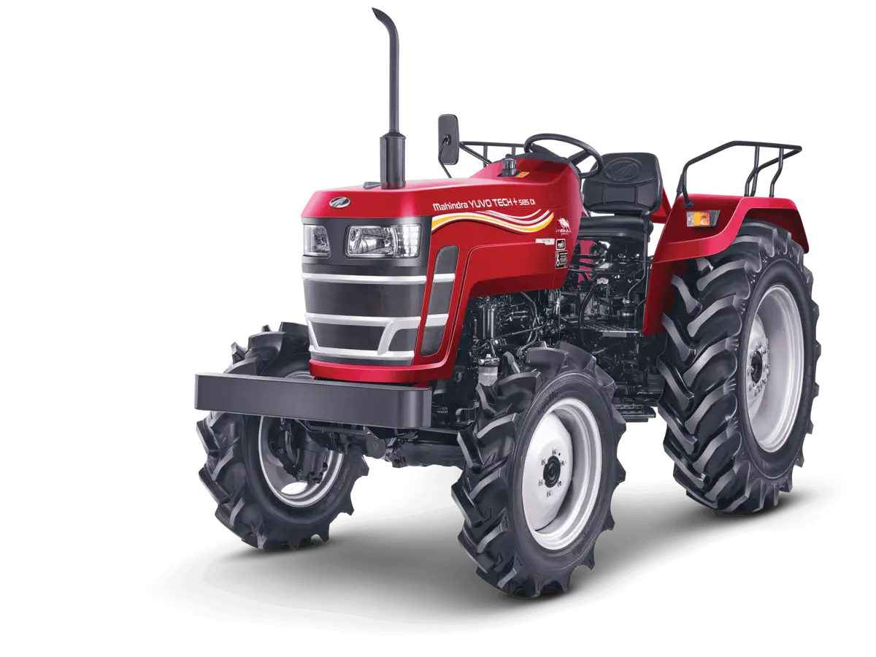

1. Meta Data (For Search Engines)

Meta Title
Mahindra Yuvo Tech+ 585, 575, 265, 275 DI Silencer | Tractech Spares

Meta Description
Buy OEM-quality Mahindra Yuvo Tech+ (585/575/265/275 DI) silencer with heat shield guard online. Durable, noise-reducing tractor exhaust at Tractech Spares.

2. On-Page Product Details

Optimized Product Title (H1 Header)
Premium Side Exhaust Silencer with Heat Guard for Mahindra Yuvo Tech+ (585 / 575 / 265 DI / 275 DI)

Product Description
Restore Your Tractor's Power with the Premium Mahindra Yuvo Tech+ Silencer Assembly
Engineered specifically for the modern Mahindra Yuvo Tech+ tractor lineup, this heavy-duty vertical side silencer is a direct OEM-grade replacement. It is fully compatible with the Yuvo Tech+ 585, 575, 265 DI, and 275 DI models.
Designed to match original factory specifications, this exhaust muffler features a integrated, heavy-duty perforated safety heat shield (jaali) to protect operators from high engine temperatures. Whether you are operating in dusty fields or muddy terrain, this silencer provides excellent backpressure control to maintain your tractor’s high fuel efficiency and legendary DI engine performance.

Key Features & Benefits:
- Integrated Safety Heat Guard: Features a built-in perforated metal shield to protect the operator and prevent accidental contact burns.
- Perfect OEM Alignment: Tailored specifically to fit the exact manifold height and bracket mounts of the Yuvo Tech+ series.
- Acoustic Noise Reduction: Advanced internal baffle chamber design effectively reduces harsh engine noise while maintaining optimal exhaust flow.
- Built to Last: Fabricated using high-grade steel with a matte black heat-resistant coating to resist rusting, scaling, and weathering.

Product Specifications:
- Brand: Tractech Spares
- Compatible Series: Mahindra YUVO TECH+ Series
- Compatible Models: Yuvo Tech+ 585, 575, 265 DI, 275 DI
- Position: Vertical / Side-Mounted Exhaust
- Special Feature: Perforated Heat Shield Guard Included

Pro-Digital Marketing Tips for This Product:
- URL Slug Structure: [tractechspares.com/products/mahindra-yuvo-tech-585-575-265-275-di-silencer-heat-guard](https://tractechspares.com/products/mahindra-yuvo-tech-585-575-265-275-di-silencer-heat-guard)
- Image Alt Text: For your product page image, use: mahindra-yuvo-tech-plus-tractor-silencer-with-heat-guard-tractech-spares.jpg
- Marketing Hook: Highlight the "With Heat Guard" (Jaali ke saath) feature prominently in your social media graphics, as farmers actively look for this safety feature when replacing older, rusted silencers.
4

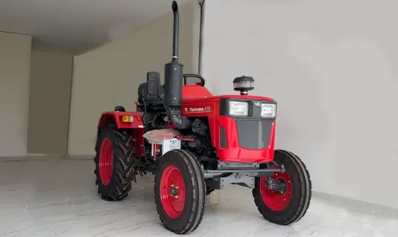

1. Meta Data (For Search Engines)

Meta Title
Mahindra Yuvraj 215 NXT Tractor Silencer with Guard | Tractech Spares

Meta Description
Buy heavy-duty replacement silencer for Mahindra Yuvraj 215 NXT mini tractor online. Includes perforated heat guard shield. Best price at Tractech Spares.

2. On-Page Product Details

Optimized Product Title (H1 Header)
Heavy-Duty Vertical Exhaust Silencer Assembly with Heat Shield for Mahindra Yuvraj 215 NXT

Product Description
Premium 2-Piece Exhaust Silencer for Mahindra Yuvraj 215 NXT Mini Tractor
Keep your compact tractor running at peak efficiency with our premium replacement Vertical Exhaust Silencer Assembly, custom-engineered for the Mahindra Yuvraj 215 NXT. Designed exactly to OEM specifications, this high-performance muffler ensures proper engine backpressure for smooth power delivery in small farmlands and orchards.
This 2-piece set features a robust main muffler body equipped with an integrated perforated safety heat guard (jaali) to prevent accidental burns during operation, accompanied by a precision-curved top extension tailpipe. Built to withstand high-vibration tasks, Tractech Spares delivers the ultimate replacement solution to keep your mini tractor reliable day in and day out.

Key Features & Benefits:
- Tailored for Yuvraj 215 NXT: Engineered as an exact dimensional match for Mahindra's premier mini tractor, ensuring an easy bolt-on installation.
- Operator Safety Guard: Features a built-in perforated metal heat shield that dissipates extreme surface temperatures, protecting the driver.
- 2-Piece Durable Build: Includes a thick-walled main muffler body and a matching bent tailpipe for efficient soot and smoke diversion.
- Weatherproof Finish: Coated in a high-temperature industrial black matte finish to actively resist rust, corrosion, and peeling.

Product Specifications:
- Brand: Tractech Spares
- Compatible Tractor Model: Mahindra Yuvraj 215 NXT
- Tractor Segment: Mini Tractor / Compact Tractor
- Assembly Type: 2-Piece Set (Muffler Body + Extension Pipe)
- Mounting Type: Bottom Flange Mount
- Finish: High-Heat Resistant Matte Black

Pro-Digital Marketing Tips for Tractech Spares:
- URL Slug Structure: [tractechspares.com/products/mahindra-yuvraj-215-nxt-mini-tractor-silencer](https://tractechspares.com/products/mahindra-yuvraj-215-nxt-mini-tractor-silencer)
- Image Alt Text: For your product page listing images, use: mahindra-yuvraj-215-nxt-tractor-silencer-pipe-tractech-spares.jpg
- Search Tag Hack: Include tags like "chota tractor silencer", "Yuvraj 215 silencer price", and "Mahindra mini tractor exhaust" in your website's hidden keywords backend to grab localized search queries from Indian farmers.
5

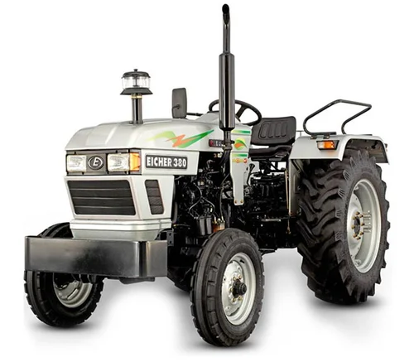

1. Meta Data (For Search Engines)

Meta Title
Eicher Tractor Silencer 380, 485, 333, 5150 (41-45 HP) | Tractech Spares

Meta Description
Buy premium vertical silencers for Eicher 333, 380, 485, and 5150 (41-45 HP) tractors online. Heavy-duty, high-performance exhaust system at Tractech Spares.

2. On-Page Product Details

Optimized Product Title (H1 Header)
Heavy-Duty Vertical Exhaust Silencer for Eicher Tractors (41 HP - 45 HP Range | 333 / 380 / 485 / 5150)

Product Description
Restore Your Engine’s Efficiency with the Premium Eicher 41-45 HP Tractor Silencer
Keep your Eicher tractor operating at its peak mechanical efficiency with our heavy-duty replacement vertical exhaust silencer. Engineered specifically for Eicher's high-demand 41 HP to 45 HP range, this premium muffler assembly offers universal, exact-fit compatibility for the Eicher 333, Eicher 380, Eicher 485, and Eicher 5150 models.
Crafted from structural-grade, thick-walled steel, this vertical silencer replicates the precise original equipment shape to ensure optimal exhaust backpressure. Proper backpressure control minimizes engine stress, maintains excellent fuel economy, and preserves that distinct, smooth Eicher engine thump. Built to conquer tough haulage and deep field tilling operations, Tractech Spares provides the reliability your farm deserves.

Key Features & Benefits:
- Multi-Model Compatibility: Custom engineered for a seamless fit across Eicher 333, 380, 485, and 5150 tractor variants.
- Sleek, High-Clearance Design: True-to-original vertical dimensions guarantee perfect hood clearance and an easy, bolt-on installation.
- Optimized Power Output: Internal structural baffling efficiently routes exhaust gas, lowering engine operating temperatures while maximizing horsepower.
- Anti-Corrosion Matte Coating: Finished with a specialized heat-resistant black coating that actively protects the pipe against intense heat, heavy moisture, and rust scaling.

Product Specifications:
- Brand: Tractech Spares (Premium Quality Aftermarket)
- Compatible Tractor Brand: Eicher
- Supported Models: Eicher 380, Eicher 485, Eicher 333, Eicher 5150 Super DI
- Engine Range: 41 HP to 45 HP Engines
- Orientation: Vertical Side-Mount with 2 bolts
- Material: Industrial-Grade material

Pro-Digital Marketing Tips for This Product:
- URL Slug Structure: [tractechspares.com/products/eicher-380-485-333-5150-tractor-silencer](https://tractechspares.com/products/eicher-380-485-333-5150-tractor-silencer)
- Image Alt Text: For your online product page image, save it as: eicher-380-tractor-silencer-exhaust-pipe-tractech-spares.jpg
- SEO Search Tag Tip: In the hidden keyword tags of your website backend, add terms like: "Eicher 380 silencer price online", "Eicher 485 exhaust muffler replacement", and "42 hp eicher tractor spare parts". This ensures you capture users typing in transactional queries!

6

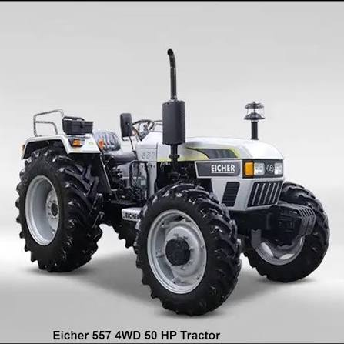

1. Meta Data (For Search Engines)

Meta Title
Eicher 551, 555, 557 Silencer (50 HP 4WD) | Tractech Spares

Meta Description
Buy heavy-duty vertical silencers for Eicher 551, 555, and 557 50 HP 4WD tractors. OEM-spec exhaust mufflers for maximum power at Tractech Spares.

2. On-Page Product Details

Optimized Product Title (H1 Header)
Heavy-Duty Wide-Barrel Vertical Silencer for Eicher 50 HP 4WD Tractors (551 / 555 / 557)

Product Description
Maximize Your Heavy-Duty Engine Performance with Premium Eicher 50 HP Silencers
Keep your high-performance machinery running at maximum capacity with our heavy-duty vertical exhaust silencer assembly, precision-engineered for the Eicher 50 HP 4WD range. This premium replacement muffler offers an exact OEM-grade fit for Eicher 551, Eicher 555, and Eicher 557 models.
Designed to accommodate the high-volume gas flow of 50 HP engines, this wide-barrel silencer ensures zero backpressure restriction. This allows your 4WD tractor to maintain optimum torque and fuel efficiency during demanding tasks like deep tilling, commercial haulage, and rotavator operations. Built with extra-thick industrial steel, Tractech Spares provides an exhaust system that perfectly preserves the signature deep, powerful Eicher engine thump.

Key Features & Benefits:
- High-Volume Wide-Barrel Design: Specifically built to manage the intensive exhaust flow of 50 HP engines without restricting horsepower.
- 4WD Heavy-Duty Built: Constructed with reinforced, thick-gauge steel sheets to withstand intense vibrations common in rough 4WD field operations.
- Perfect Bolt-On Fit: Direct dimensional replica for Eicher 551, 555, and 557 models, ensuring a quick, zero-modification installation.
- Ultra-Durable Thermal Shield Coating: Finished with a professional-grade, heat-resistant matte black coating that prevents rust scaling and thermal discoloration.

Product Specifications:
- Brand: Tractech Spares (Premium High-End Variant)
- Compatible Tractor Brand: Eicher
- Supported Models: Eicher 557 4WD, Eicher 551, Eicher 555 (50 HP Range)
- Orientation: Vertical Side-Mount (Wide Body)
- Material: Heavy-Gauge Industrial

Pro-Digital Marketing Tips for This Product:
- URL Slug Structure: [tractechspares.com/products/eicher-551-555-557-50hp-4wd-tractor-silencer](https://tractechspares.com/products/eicher-551-555-557-50hp-4wd-tractor-silencer)
- Image Alt Text: To ensure Google Images pulls up your product for buying searches: eicher-557-4wd-tractor-silencer-heavy-duty-tractech-spares.jpg
- High-Converting Search Tags: In your website backend, add specific high-intent keywords: "Eicher 557 silencer price", "Eicher 551 heavy duty exhaust pipe", "50 hp tractor spare parts online", and "Eicher 4wd tractor silencer original".
7

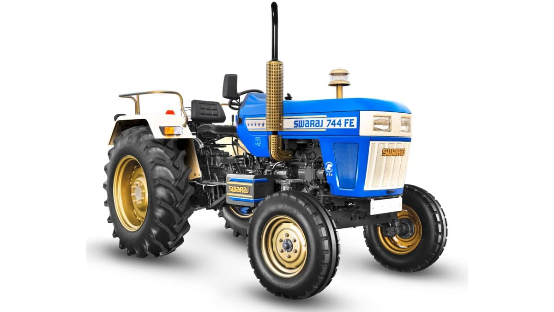

1. Meta Data (For Search Engines)

Meta Title
Swaraj 744 & 855 FE/XT Silencer (Half/Full Jali) | Tractech Spares

Meta Description
Buy premium Swaraj 744 FE/XT and 855 FE/XT tractor silencers online. Choose from heavy-duty Half Jali or Full Jali heat shields at Tractech Spares.

2. On-Page Product Details

Optimized Product Title (H1 Header)
Heavy-Duty Vertical Exhaust Silencer for Swaraj Tractors (744 FE & XT / 855 FE & XT) – Available in Half & Full Jali

Product Description
Give Your Swaraj Tractor the Ultimate Protection with Premium Half/Full Jali Silencers
Maintain the legendary roar and top-tier engine efficiency of your tractor with our premium replacement vertical exhaust silencer assembly, designed specifically for the Swaraj 744 FE, 744 XT, 855 FE, and 855 XT models.
Engineered to match strict factory standards, these silencers are available in two popular variations to fit your exact preference: Half Jali (covering the lower assembly) and Full Jali (covering the full height of the muffler barrel). The heavy-duty perforated metal guard protects the operator from severe engine heat while adding that iconic, rugged Swaraj look. Built to handle intense tilling, puddling, and heavy trolley haulage, Tractech Spares ensures perfect exhaust backpressure without robbing your tractor of its signature horsepower.

Key Features & Benefits:
- Dual Configurations Available: Choose between Half Jali or Full Jali options to customize safety and appearance.
- Perfect Swaraj Fitment: Seamless, direct-fit design for Swaraj 744 and 855 models across both FE and high-torque XT lineups.
- Premium Heat Dissipation: The reinforced perforated outer guard significantly reduces surface temperature contact risks.
- Heavy-Gauge Steel Construction: Crafted using thick-walled industrial steel with a high-temperature rust-resistant base coat to resist field wear and scaling.

Product Specifications:
- Brand: Tractech Spares (Premium Aftermarket)
- Compatible Tractor Brand: Swaraj
- Supported Models: Swaraj 744 FE, 744 XT, Swaraj 855 FE, 855 XT
- Guard Options: Perforated Metal Jali (Half Shield / Full Shield Available)
- Orientation: Vertical Side Exhaust

Pro-Digital Marketing Tips for This Product:
- URL Slug Structure: [tractechspares.com/products/swaraj-744-855-fe-xt-silencer-half-full-jali](https://tractechspares.com/products/swaraj-744-855-fe-xt-silencer-half-full-jali)
- Image Alt Text: For your product variant image uploads, use: swaraj-855-tractor-silencer-full-jali-tractech-spares.jpg and swaraj-744-silencer-half-jali.jpg
- High-Converting Search Tags: On your website's backend dashboard, insert regional, high-intent search tags: "Swaraj 855 silencer jali price", "Swaraj 744 XT exhaust pipe online", "Swaraj tractor full jali silencer", and "Swaraj 855 original sound muffler".
8
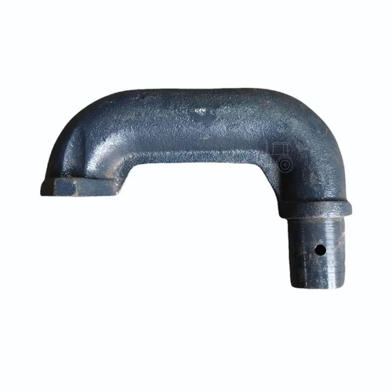

1. Meta Data (For Search Engines)

Meta Title
Swaraj 744 & 855 FE/XT Silencer Elbow (Exhaust Bend) | Tractech Spares

Meta Description
Buy heavy-duty cast-iron exhaust silencer elbows for Swaraj 744 FE/XT & 855 FE/XT models. Get leak-proof tractor manifold bends at the best price on Tractech Spares.

2. On-Page Product Details

Optimized Product Title (H1 Header)
Heavy-Duty Cast Iron Exhaust Silencer Elbow for Swaraj Tractors (744 FE & XT / 855 FE & XT)

Product Description
Ensure a Leak-Free Exhaust Flow with Premium Swaraj 744 & 855 Silencer Elbows
Keep your engine breathing correctly and prevent hazardous exhaust leaks with our premium replacement Silencer Exhaust Elbow, custom-engineered for Swaraj 744 FE, 744 XT, 855 FE, and 855 XT tractors. This critical pipe adapter routes high-pressure exhaust gases securely from the engine manifold up into your main vertical silencer assembly.
As pictured, this exhaust bend is cast from ultra-durable, high-grade industrial cast iron. It is specifically formulated to withstand the intense thermal cycling and backpressures generated during strenuous farm applications like deep tilling or commercial trolley haulage. With precision-machined connection ends, this elbow delivers a factory-accurate, leak-proof seal that eliminates performance-robbing exhaust drops and annoying rattles.

Key Features & Benefits:
- Rugged Cast-Iron Construction: Built from thick-gauge, wear-resistant cast iron that resists cracking, warping, and heat fatigue over long operational hours.
- Perfect Dimensional Match: Engineered as a direct OEM-matching swap for the entire Swaraj 744 and 855 series (covering both FE and XT engine variants).
- Leak-Proof Connection: Precision-tapered port ends ensure an air-tight fit against the manifold, maintaining exact engine backpressure and optimal fuel efficiency.
- Anti-Rust Industrial Coating: Finished with a thick, heat-resistant protective black layer to defend against moisture, outdoor scaling, and early corrosion.

Product Specifications:
- Brand: Tractech Spares (Premium Replacement Range)
- Compatible Tractor Brand: Swaraj
- Supported Models: Swaraj 744 FE, Swaraj 744 XT, Swaraj 855 FE, Swaraj 855 XT
- Component Material: Industrial-Grade Solid Cast Iron
- Component Type: Exhaust Manifold Elbow / Silencer Bend Pipe

Pro-Digital Marketing Tips for This Product:
- URL Slug Structure: Keep it highly indexable by Google bots: [tractechspares.com/products/swaraj-744-855-fe-xt-silencer-exhaust-elbow](https://tractechspares.com/products/swaraj-744-855-fe-xt-silencer-exhaust-elbow)
- Image Alt Text: Ensure Google Images pulls this up when mechanics search for it visually: swaraj-855-tractor-silencer-elbow-bend-pipe-tractech-spares.jpg
- Cross-Selling Hack: Place this product as a mandatory cross-sell add-on or "Frequently Bought Together" recommendation on your main Swaraj 744/855 Silencer (Half/Full Jali) product pages. When a farmer replaces a rusted silencer, they almost always need a fresh, clean elbow bend to match it!
9
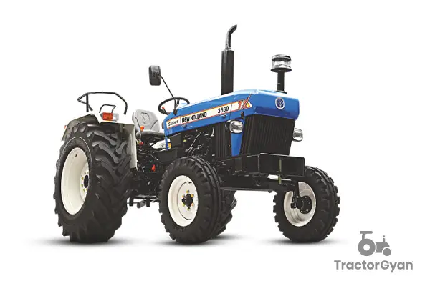

1. Meta Data (For Search Engines)

Meta Title
New Holland 3630 Tractor Silencer (Exhaust Muffler) | Tractech Spares

Meta Description
Buy heavy-duty replacement silencer for New Holland 3630 TX Plus online. Get durable, OEM-spec tractor exhaust systems at the best price on Tractech Spares.

2. On-Page Product Details

Optimized Product Title (H1 Header)
Heavy-Duty Vertical Exhaust Silencer for New Holland Tractor (3630 TX / TX Plus / Super)

Product Description
Restore Engine Power and Precision with the Premium New Holland 3630 Silencer
Maintain the peak horsepower, smooth fuel delivery, and signature exhaust note of your machine with our heavy-duty replacement vertical silencer. Custom-engineered precisely for the legendary New Holland 3630 series (including TX, TX Plus, and Super editions), this premium exhaust muffler offers an absolute direct-fit, zero-modification installation.
Crafted from structural-grade, thick-gauge industrial steel, this vertical side exhaust replicates original factory configurations. It ensures the exact backpressure control required by New Holland’s high-torque engines, allowing you to maximize fuel economy during intensive field tasks like rotavator tilling, harvesting, and heavy trolley haulage. With its streamlined, high-clearance profile, Tractech Spares provides the rugged reliability needed to withstand the harshest farming environments.

Key Features & Benefits:
- Perfect 3630 Compatibility: Designed as an exact factory-spec dimensional replacement for the entire New Holland 3630 tractor lineup.
- Preserves Original Sound: Advanced internal baffle routing efficiently dampens excessive noise while maintaining that iconic, crisp New Holland engine note.
- Optimized Exhaust Flow: Prevents backpressure restrictions to lower engine operating temperatures and unlock maximum torque output.
- High-Heat Protective Coating: Coated in a professional-grade, rust-resistant matte black finish that actively resists paint peeling, thermal discoloration, and weathering.

Product Specifications:
- Brand: Tractech Spares (Premium Aftermarket Replacement)
- Compatible Tractor Brand: New Holland
- Supported Models: New Holland 3630 TX, 3630 TX Plus, 3630 Super
- Orientation: Vertical Side-Mount
- Material: Heavy-Gauge Carbon Steel

Pro-Digital Marketing Tips for Tractech Spares:
- URL Slug Structure: Keep it short, structured, and easy for search bots to index: [tractechspares.com/products/new-holland-3630-tx-plus-tractor-silencer](https://tractechspares.com/products/new-holland-3630-tx-plus-tractor-silencer)
- Image Alt Text: Label your product photos cleanly to dominate Google Images traffic: new-holland-3630-tractor-silencer-exhaust-muffler-tractech-spares.jpg
- High-Yield Backend Search Tags: In your website’s backend keyword tags, add high-intent variations: "New Holland 3630 silencer price online", "New holland tractor exhaust pipe replacement", "3630 tx plus original sound silencer", and "New Holland spare parts near me".

10
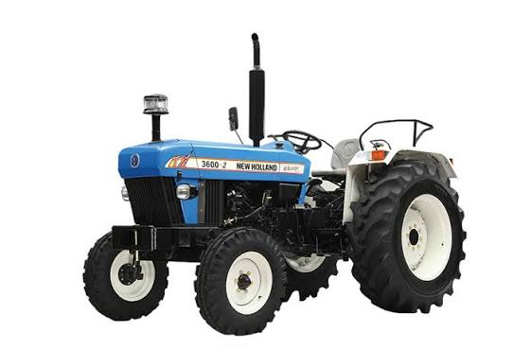

1. Meta Data (For Search Engines)

Meta Title
New Holland 3600-2 Tractor Silencer (Exhaust Pipe) | Tractech Spares

Meta Description
Buy heavy-duty replacement vertical silencer for New Holland 3600-2 TX online. Get OEM-quality tractor exhaust mufflers at the best price on Tractech Spares.

2. On-Page Product Details

Optimized Product Title (H1 Header)
Heavy-Duty Vertical Exhaust Silencer for New Holland 3600-2 Tractor (TX / All Rounder Series)

Product Description
Keep Your Tractor Running Efficiently with Premium New Holland 3600-2 Silencers
Maintain the peak horsepower, operational reliability, and clean exhaust flow of your machine with our heavy-duty replacement vertical silencer. Custom-engineered as a precise direct-fit replacement for the widely popular New Holland 3600-2 TX and 3600-2 All Rounder variants, this exhaust assembly requires zero modification for installation.
Constructed from structural-grade, thick-walled industrial steel, this vertical muffler replicates original factory dimensions perfectly. It delivers the exact internal backpressure dynamics required by the 3600-2 engine to ensure smooth fuel delivery and peak performance during demanding tasks like rotavator tilling, harvesting, and heavy haulage. Trust Tractech Spares to give your tractor the durable exhaust solution it needs to handle tough field conditions year after year.

Key Features & Benefits:
- Exact Factory Alignment: Built precisely to match the dimensions and mounting orientation of the New Holland 3600-2 series.
- Preserves Clean Exhaust Notes: Advanced internal structural layout effectively suppresses loud engine racket while letting the classic New Holland tone shine through.
- Optimized Engine Backpressure: Eliminates gas restrictions to prevent engine overheating and unlock optimal torque.
- Heat-Resistant Shield Finish: Coated in a professional-grade, rust-resistant matte black finish that fights off thermal discoloration, paint peeling, and weather rust.

Product Specifications:
- Brand: Tractech Spares (Premium Quality Aftermarket)
- Compatible Tractor Brand: New Holland
- Supported Models: New Holland 3600-2 TX, 3600-2 All Rounder
- Orientation: Vertical Side Exhaust
- Material: Heavy-Gauge Cold-Rolled Steel

Pro-Digital Marketing Tips for Tractech Spares:
- URL Slug Structure: Keep it clear for search engines: [tractechspares.com/products/new-holland-3600-2-tractor-silencer-exhaust](https://tractechspares.com/products/new-holland-3600-2-tractor-silencer-exhaust)
- Image Alt Text: Secure traffic from Google Images search tabs: new-holland-3600-2-tractor-silencer-pipe-tractech-spares.jpg
- High-Converting Search Tags: Insert these in your backend metadata: "New Holland 3600-2 silencer price", "New holland 3600-2 exhaust pipe online", "3600-2 tx all rounder tractor spare parts", and "heavy duty tractor silencer black".
11

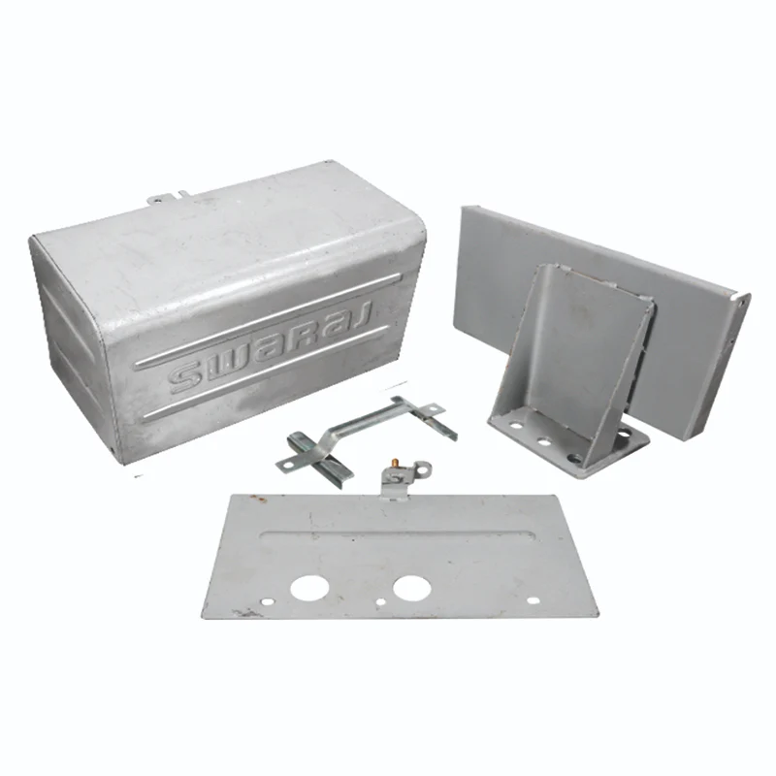

1. Meta Data (For Search Engines)

Meta Title
Tractor Battery Box (Heavy Duty Metal Enclosure) | Tractech Spares

Meta Description
Buy rugged mild steel tractor battery boxes online. Protect your agricultural battery from dust, acid corrosion, and field vibrations at the best price.

2. On-Page Product Details

Optimized Product Title (H1 Header)
Heavy-Duty Mild Steel Tractor Battery Box Enclosure (Universal & Model-Specific Fitting)

Product Description
Shield Your Investment with Premium Wear-Resistant Tractor Battery Boxes
Protect your vehicle’s electrical core from brutal agricultural conditions with our premium replacement Tractor Battery Box Enclosure. Purpose-built to securely house heavy-duty tractor batteries, this tough protective casing safeguards your high-value battery assembly against devastating acid spills, heavy moisture buildup, thick dust accumulation, and severe environmental scaling.
Constructed from structural-grade, thick-gauge Mild Steel (MS) sheets, this box is meticulously engineered to withstand the relentless thermal cycling and intense mechanical jolts of everyday farming. Designed with precise factory-matched mounting tabs, it isolates the battery cell from frame vibrations, preventing internal grid damage and drastically extending your vehicle's overall electrical lifespan.

Key Features & Benefits:
- Thick-Gauge Mild Steel Construction: Forged from high-grade sheet metal that actively resists physical dents, impact damage, and rough structural warping.
- Anti-Corrosive Shielding: Pre-treated with a thick, chemical-resistant industrial coating designed to neutralize battery acid leaks and block structural rust.
- Vibration-Dampening Architecture: Secure bolt-on placement prevents the battery from bouncing or shifting during high-stress operations like deep rotavator tilling.
- Universal & Model-Specific Options: Engineered to seamlessly accommodate standard high-Ah commercial tractor batteries across popular Indian tractor lineups.

Product Specifications:
- Brand: Tractech Spares (Premium Aftermarket Hardware)
- Component Type: Tractor Battery Storage / Outer Panel Assembly
- Material: Heavy-Gauge Cold-Rolled Mild Steel (MS)
- Surface Treatment: Powder Coated / Paint Coated Rust-Resistant Finish
- Compatibility: Universal Fitting Options Available for Swaraj, Mahindra, Massey Ferguson, John Deere, Tafe, and Eicher tractor models.

Pro-Digital Marketing Tips for Tractech Spares:
- URL Slug Structure: Ensure it is optimized cleanly for search engine web crawlers: [tractechspares.com/products/heavy-duty-metal-tractor-battery-box](https://tractechspares.com/products/heavy-duty-metal-tractor-battery-box)
- Image Alt Text Tagging: Capture organic traffic using focused visuals on Google Images: mild-steel-tractor-battery-box-enclosure-tractech-spares.jpg
- High-Intent Backend Search Tags: Inject these directly into your backend website settings to drive high-converting traffic: "Mahindra tractor battery box price", "Swaraj mild steel battery cover online", "universal tractor battery storage tray", and "Massey Ferguson tractor body replacement parts".

12

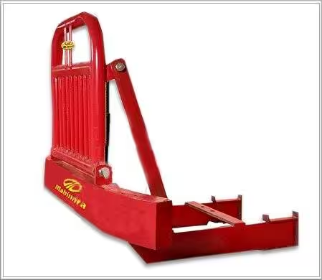

1. Meta Data (For Search Engines)

Meta Title
Heavy Duty Tractor Bumper & Front Grille Guard | Tractech Spares

Meta Description
Buy ultra-strong steel tractor front bumpers online. Protect your bonnet, headlights, and radiator from impact with heavy bull bars at Tractech Spares.

2. On-Page Product Details

Optimized Product Title (H1 Header)
Heavy-Duty Steel Front Tractor Bumper & Reinforced Bull Bar Guard

Product Description
Shield Your Front-End and Improve Stability with Premium Tractor Bumpers
Defend your vehicle against severe field impacts, accidental collisions, and dense brush damage with our premium Heavy-Duty Front Tractor Bumper. Custom-engineered to provide a bulletproof shield for your tractor’s front assembly, this rugged bull bar protects expensive, high-risk components like the radiator, headlights, and front sheet metal bonnet panels.
As pictured, this bumper features a high-clearance, integrated upper grille guard welded to a solid, reinforced base frame. Constructed from structural-grade, thick-walled channel steel, it doesn't just offer unmatched impact absorption—it also serves as an essential counterweight. By adding solid mass to the front axle, it drastically improves stability, steering control, and tire traction when hauling heavy commercial trolleys or operating massive rear-mounted implements.

Key Features & Benefits:
- Reinforced Steel Engineering: Built from thick-gauge, high-tensile structural channel iron and heavy tubular steel designed to absorb massive frontal shocks without bending.
- Total Frontal Protection: Extended upper grille design wraps securely around the front end, keeping flying debris, branches, and field obstacles away from your headlights and radiator.
- Enhanced Front Counterweight Stability: Significantly adds balanced forward mass to eliminate front-end lifting and wheelies during high-torque haulage or deep plowing.
- Direct Bolt-On Chassis Fitment: Engineered with precision-aligned heavy mounting brackets that secure directly to the main tractor chassis frame for zero-flex stability.
- Premium High-Gloss Coating: Finished with a thick, weather-resistant industrial paint layer to actively combat rust, outdoor scaling, and sun fading.

Product Specifications:
- Brand: Tractech Spares (Premium Agricultural Range)
- Component Type: Front Bumper / Bull Bar / Crash Guard
- Material: High-Tensile Structural Channel & Tubular Steel
- Mounting Type: Direct Chassis Bolt-On
- Supported Brands: Model-specific configurations available for Mahindra, Swaraj, New Holland, Massey Ferguson, and John Deere.

Pro-Digital Marketing Tips for Tractech Spares:
- URL Slug Structure: Optimized cleanly for indexing: [tractechspares.com/products/heavy-duty-front-tractor-bumper-bull-bar](https://tractechspares.com/products/heavy-duty-front-tractor-bumper-bull-bar)
- Image Alt Text Tagging: Capture buyers searching visually for heavy modifications: mahindra-tractor-front-bumper-steel-guard-tractech-spares.jpg
- High-Converting Search Tags: Insert these in your e-commerce platform backend: "Mahindra tractor bumper price online", "heavy weight tractor front guard", "Swaraj tractor bull bar steel", and "commercial tractor trolley bumper modification".
13

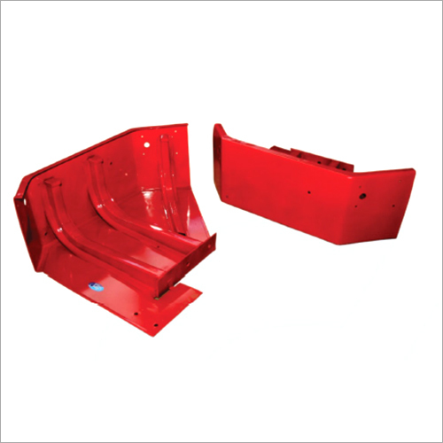

1. Meta Data (For Search Engines)

Meta Title
Tractor Mudguard & Rear Metal Fender Replacements | Tractech Spares

Meta Description
Buy heavy-duty mild steel tractor mudguards online. Discover rust-proof, vibration-resistant front & rear tractor fenders at the best price on Tractech Spares.

2. On-Page Product Details

Optimized Product Title (H1 Header)
Heavy-Duty Structural Steel Tractor Mudguard Assembly (Premium Rear & Front Fenders)

Product Description
Defend Your Machine and Operator with Premium Heavy-Gauge Tractor Mudguards
Keep flying debris, stone chips, wet slush, and field debris entirely isolated from your operating platform with our premium replacement Tractor Mudguard Fenders. Engineered to serve as a bulletproof structural barrier over front and rear tires, these high-tensile sheet metal guards shield critical undercarriage parts, wiring lines, and external accessories from aggressive wear.
Forged from premium-grade Cold-Rolled Mild Steel (MS) sheets, this mudguard collection is specifically designed to handle the absolute harshest agricultural realities. With optimized thickness profiles and factory-matched internal reinforcement ribs, these fenders deliver a rigid, zero-flex mounting base. This provides the structural integrity needed to safely bolt on heavy side-helper cushion seats, electrical indicator guards, or large metal toolboxes without risking body panel distortion or cracks.

Key Features & Benefits:
- Thick-Gauge Steel Engineering: Fabricated using high-density sheet iron that easily absorbs tyre-thrown stone impacts, preventing unsightly panel dimpling and bending.
- Load-Bearing Rigidity: Highly reinforced frame geometry comfortably accommodates heavy passenger side seats and structural modifications.
- Factory-Spec Alignment: Engineered with high-precision, pre-drilled bolt configurations for an absolute drop-in, zero-modification installation on your chassis.
- Multi-Layer Anti-Rust Primer: Treated with a deep, weather-resistant base paint to aggressively eliminate corrosion, chemical scaling, and under-fender rust pitting.

Product Specifications:
- Brand: Tractech Spares (Premium Body Parts Range)
- Component Type: Tractor Mudguard / Rear Wheel Fender Assembly
- Material Options: Heavy-Gauge Cold-Rolled Mild Steel (MS) / Premium FRP
- Surface Treatment: Smooth Painted Finish / Anti-Corrosive Industrial Primer
- Supported Brands: Model-accurate variants engineered perfectly for Swaraj (744/855), Mahindra (275/575), John Deere (5310), Massey Ferguson (1035), Sonalika, and New Holland.

Pro-Digital Marketing Tips for Tractech Spares:
- URL Slug Structure: Keep it exceptionally clean for crawling spiders: [tractechspares.com/products/heavy-duty-steel-tractor-mudguard-fender](https://tractechspares.com/products/heavy-duty-steel-tractor-mudguard-fender)
- Image Alt Text Optimization: Dominate visual searches on industrial parts networks: mahindra-575-tractor-rear-mudguard-steel-fender-tractech-spares.jpg
- High-Converting Backend Tags: Embed these search terms into your store’s platform: "Swaraj 855 tractor mudguard price online", "heavy sheet metal tractor rear fender", "John Deere green tractor mudguard assembly", and "Massey Ferguson round fender body parts".
14

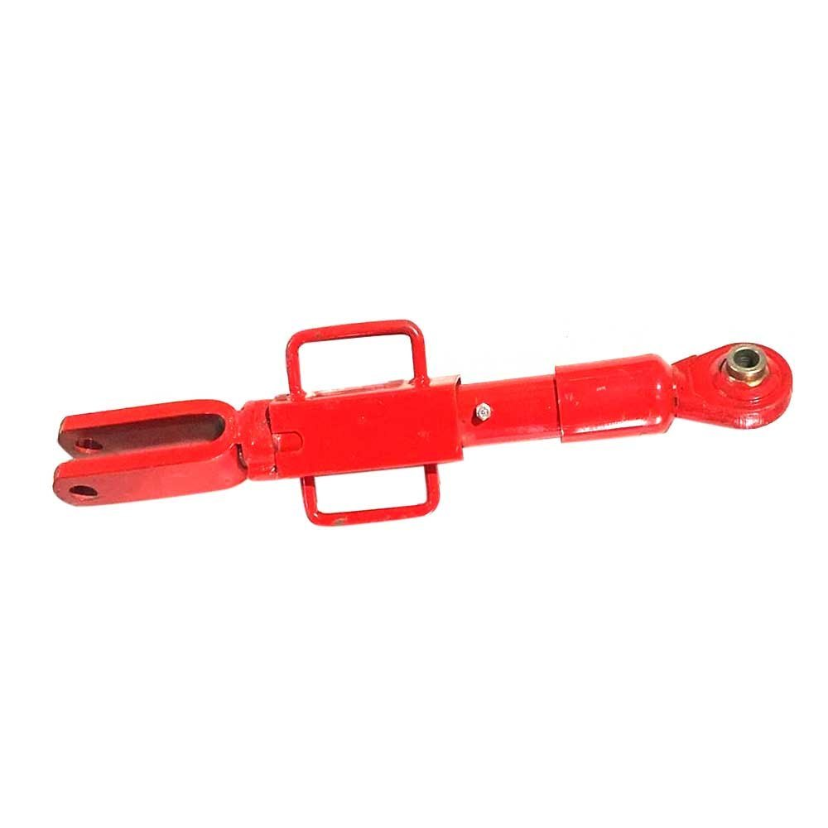

1. Meta Data (For Search Engines)

Meta Title
Tractor Levelling Assembly & 3-Point Linkage Lift Rods | Tractech Spares
Meta Description
Buy heavy-duty adjustable tractor levelling boxes online. Discover forged steel linkage levelling arms and lift rod assemblies at Tractech Spares.

2. On-Page Product Details

Optimized Product Title (H1 Header)
Heavy-Duty Adjustable Tractor Levelling Assembly (Premium 3-Point Linkage Lift Rod Box)

Product Description
Achieve Perfect Implement Depth and Alignment with Premium Tractor Levelling Assemblies
Take complete control over your field tillage depth, leveling balance, and implement tracking with our premium replacement Tractor Levelling Assembly. Positioned as a critical vertical link within your tractor's rear 3-point hitch geometry, this heavy-duty adjustable turnbuckle connects the hydraulic lift arm to the lower draft link, allowing you to fine-tune the lateral angle of heavy soil-engaging implements.
As pictured, this structural levelling rod features a robust central turnbuckle body equipped with a twin-handle grip for effortless, quick manual adjustments out in the field. Forged from high-tensile, heat-treated carbon steel, it features precision-machined internal threads that resist stripping under massive drawbar pressure. Fitted with a heavy-duty clevis end on one side and a hardened ball-joint eyelet on the other, this assembly eliminates sloppy linkage play and stands up to intense, rocky field impacts.

Key Features & Benefits:
- High-Tensile Forged Steel Construction: Engineered from high-density, solid carbon steel designed to withstand immense hydraulic lifting forces without bending or fracturing.
- Smooth-Action Threaded Adjustment: Precision-cut internal threads allow for fluid, non-jamming length calibration, even when supporting the deadweight of heavy farm implements.
- Ergonomic Twin-Handle Grip: Built with an integrated, welded central handle configuration that makes adjusting implement level quick, safe, and tool-free.
- Eliminates Linkage Play: Hardened internal ball-joints and tight-tolerance clevis pins maintain stable implement tracking, ensuring uniform plowing and seed distribution.
- Industrial Anti-Rust Coating: Finished with a thick, high-visibility protective paint shield that actively stops thread corrosion, rust binding, and weathering.

Product Specifications:
- Brand: Tractech Spares (Premium Quality Aftermarket Range)
- Component Type: 3-Point Linkage Levelling Box / Adjustable Lift Rod Assembly
- Material: Forged, Heat-Treated Structural Carbon Steel
- Ends Configuration: Heavy Clevis Joint to Hardened Swivel Ball Eyelet
- Compatibility: Precision-tailored variations available for all major tractor lines including Mahindra, Swaraj, Massey Ferguson, John Deere, Sonalika, New Holland, and Escorts/Farmtrac.

Pro-Digital Marketing Tips for Tractech Spares:
- URL Slug Structure: Keep it highly crawlable for search engine crawlers: [tractechspares.com/products/heavy-duty-adjustable-tractor-levelling-assembly](https://tractechspares.com/products/heavy-duty-adjustable-tractor-levelling-assembly)
- Image Alt Text Tagging: Capture mechanics searching visually for linkage replacements: adjustable-tractor-levelling-box-assembly-rod-tractech-spares.jpg
- High-Converting Backend Search Tags: Add these high-intent phrases inside your store's backend: "Mahindra tractor levelling box price online", "Swaraj 855 lift rod assembly", "heavy duty tractor turnbuckle leveling arm", and "3 point linkage tractor spare parts near me".

15

